Diversity in India

Vocabulary

- Diversity

- Equality

- Untouchability

- Fundamental rights

- Constitution

Questions

- What are the different languages spoken in India?

- What are the different festivals celebrated in india?

- What is the traditional dress of Punjab?

- Idli, Dosa is the traditional food of which state?

- What do all these indicate?

The occurence of various types of living beings which differ from one another in external form and appearance, internal structure, nutrition, behavior, habitat etc.

India is a nation full of diversities. You move from one place to another, you will find a lot of diversity in Indian society in the two regions, say diversities in language, food, clothing, festivals, music, dance, etc. But if we observe them carefully, they do have some similarities but people do the same things in their own and different ways.
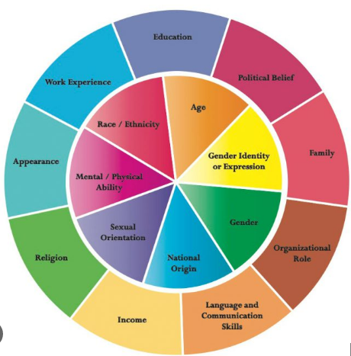

Did you know?
Jawaharlal Nehru used this famous phrase 'Unity in Diversity' in his book 'Discovery of India'.
The geography and the history of a place play a vital role in the life of that region.The food or clothing system of the mountain region will be different from a region near the sea.
We have different types of diversity such as
Geographical diversity
Economic diversity
Religious diversity
Cultural diversity
1.Compare and write differences between these two places.
Points to compare | Ladakh | kerala
Location | Ladakh is located in the north of the country.It is surrounded by the Himalayas and has a cold climate | Kerala is located in the south. It lies close to the Indian ocean and the Arab sea hence has a hot and humid climate.
Political location | Ladakh is a cold desert and is one of the union territories of India. | Kerala is an Indian state and has a tropical wet climate.
climate | It remains frozen for almost the entire year and the temperature falls below zero after sunset. | The weather is hot and humid around the year.
Language | Bhoti or classical Tibetan is the language spoken in Ladakh. | Malayalam is the language that is spoken in Kerala.
Famous for | Ladakh is famous for its Pashmina wool. Ladakh is also known as Little Tibet. | Kerala is known for its spices. A wide variety of spices like pepper, cardamom, clove, cinnamon, turmeric, etc are cultivated in Kerala.

What does diversity add to our lives ?
- People of various races, ethnic backgrounds, religions, and social groups can communicate and learn from one another because of diversity.
- One of the essential aspects that enriches our life in various ways is diversity.
- It increases the value of respecting one another and appreciating one's time.

